More Than Half of US Social Network Users Will Be Mobile-Only in 2019
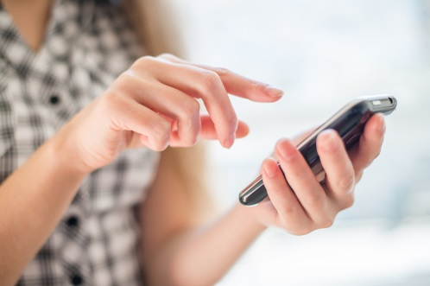
As smartphone use grows, fewer Americans are using desktops and laptops to access the internet. The number of US smartphone users will reach 232.8 million in 2019, surpassing desktop/laptop internet users (228.9 million) for the first time. And the number of those who access the internet exclusively on a mobile device will grow by 10.6%, reaching 55.1 million users.
eMarketer 4.26.19
https://www.emarketer.com/content/more-than-half-of-social-network-users-will-be-mobile-only-in-2019?ecid=NL1001
Image credit:
http://www.todayifoundout.com/wp-content/uploads/2014/10/texting.jpg

