Movie Releases Send More Customers to Streaming Services
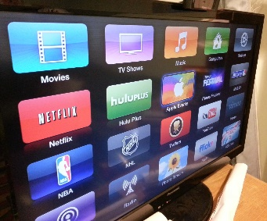
Hub Entertainment Research reports that 13% of new subscribers to streaming services chose HBO Max in December, almost double the service's November market share. "Theatrical" movies drove the decision for 12%, and the same share of new Disney+ customers cited movies as their reason for signing up.
Media Play News 2/15/21
https://www.mediaplaynews.com/research-consumers-flocked-to-hbo-max-in-december-to-watch-new-movies/
Image credit:
https://add-vodka.com/wp-content/uploads/2017/10/TV.jpeg

