Microsoft's Activision Blizzard Deal Levels Up Ad Potential
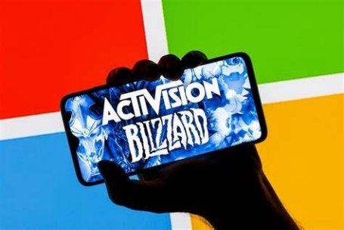
Microsoft's acquisition of Activision Blizzard, the largest video game deal in history, is expected to drive $1.4 billion in in-game ad sales for the tech giant by 2030. Microsoft is reportedly working on an adtech stack for console and PC games, and experts say the opportunities for in-app purchases and sponsorships, unique data on gamers and brand-safe marketing environments will be enticing for advertisers.
Adweek 10/16/23
https://www.adweek.com/brand-marketing/microsofts-activision-blizzard-deal-will-be-a-new-lure-for-brands/#
Image credit:
https://images.idgesg.net/images/article/2023/09/microsoft-activision-blizzard-100946558-large.jpg?auto=webp&quality=85,70

