NABOB, NRB Back Local Radio Freedom Act
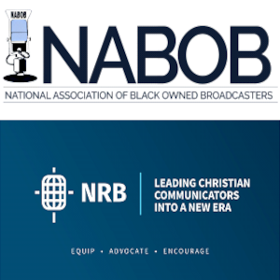
The National Association of Black-Owned Broadcasters and the National Religious Broadcasters have both voiced support for the Local Radio Freedom Act, warning that imposing royalty fees on radio could put financial pressures on Black-owned stations and potential divert resources away from community initiatives. A pair of Democratic representatives have joined the LRFA's 130 previous co-sponsors.
All Access Music Group 2.28.23
https://www.allaccess.com/net-news/archive/story/225877/local-radio-freedom-act-american-music-fairness-ac

