Music Criticism in the Time of Stans and Haters
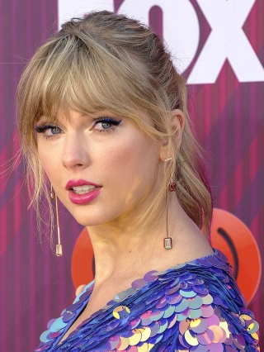
The language of Swift’s message was benign; still, it unleashed the feverish collective will of her millions of followers and fans, who flooded social-media accounts belonging to Borchetta and Braun. The episode made clear that Swift, like many popular artists, holds a powerful trump card: a massive, loyal social-media following that will advocate on her behalf.
Columbia Journalism Review 3.6.20
https://www.cjr.org/criticism/stan-hater-music-criticism.php?mc_cid=f0de353d07&mc_eid=51f6ebc94b
Image credit:
https://www.yournextshoes.com/wp-content/uploads/2019/03/Taylor-Swift-pink-hair.jpg

