Music Industry Making Money Again
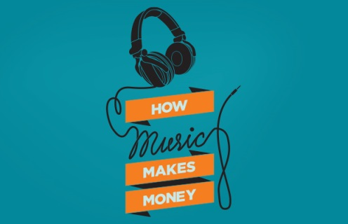
And that’s thanks to the new subscription models being launched by online streaming companies, according to cNet. Sales from streaming music were up 8.1 percent to $3.4 billion in the first six months of 2016 compared with the same period last year, according to the website. In the first half of 2015, revenue was down 0.5 percent.
Radio Ink 9.21.16
http://radioink.com/2016/09/21/music-industry-making-money/?utm_source=ActiveCampaign&utm_medium=email&utm_content=She+s+Changing+The+%22Toxic%22+Culture+At+Cumulus&utm_campaign=Wednesday+9+21+Berner+Culture
Image source:
https://www.bing.com/images/search?q=music+industry&view=detailv2&&id=B0E255800CE5D4B3582C3CA9B224339AE904D538&selectedIndex=0&ccid=1b1sli0y&simid=608023742269296599&thid=OIP.Md5bd6c962d322998a872ad1d91dd0217o0&ajaxhist=0

