Musk Completes Twitter Deal, Tries To Reassure Advertisers
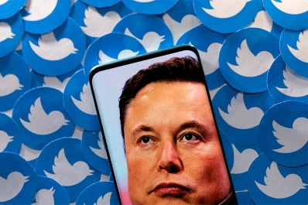
Elon Musk's $44 billion purchase of Twitter has been completed and sources report his first move was to fire several leaders, including CEO Parag Agrawal and Vijaya Gadde, Twitter's lead for legal, public policy & trust and safety. Earlier, Musk addressed advertisers ahead of the completion of the deal, promising the platform wouldn't "become a free-for-all hellscape." Despite that, many ad executives still expressed concern over Musk's approach to brand safety.
MediaPost Communications (free registration) 10/27/22
https://www.mediapost.com/publications/article/379189/in-letter-to-advertisers-musk-vows-twitter-wont.html
Image credit:
https://media.interaksyon.com/wp-content/uploads/2022/05/twitter-elon-musk.jpg

