My Life As An iPhone Reporter
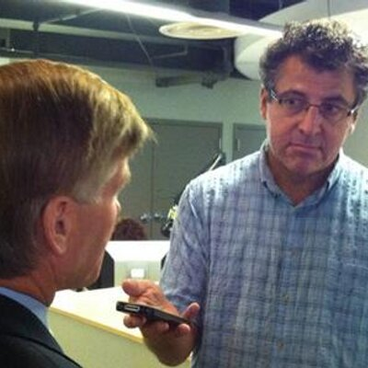
For nearly two decades, Neal Augenstein has been an award-winning reporter with WTOP-FM and wtop.com. He's believed to be one of the first major-market radio reporters to do all his field reporting on an iPhone. Augenstein says that, in 2015, photo and video-sharing sites like Twitter, Facebook, and Instagram are where news is broken, "generally in visually-oriented, easily-digested tidbits."
Radio Ink 4.2.15
http://www.radioink.com/Article.asp?id=2912523&spid=24698

