Myanmar Court Jails Reuters Reporters for Seven Years in Landmark Secrets Case
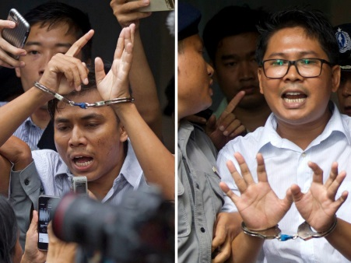
A judge said Wa Lone, 32, and Kyaw Soe Oo, 28, breached the colonial-era Official Secrets Act when they collected and obtained confidential documents. “The defendants ... have breached Official Secrets Act section 3.1.c, and are sentenced to seven years,” the judge said, adding that the time served since they were detained on Dec. 12 would be taken into account. The defense can appeal the decision to a regional court and then the Supreme Court.
Reuters 9.4.18
https://www.reuters.com/article/us-myanmar-journalists/myanmar-judge-convicts-two-reuters-reporters-in-landmark-secrets-case-idUSKCN1LJ09E?utm_source=twitter&utm_medium=Social
Image credit:
https://newsline.com/wp-content/uploads/2018/09/31845/Kyaw-Soe-Oo-Wa-Lone.jpg

