NAB Appeals CRB Decision On Streaming Rates
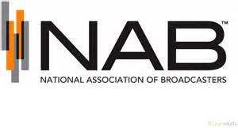
The National Association of Broadcasters has asked a federal appeals court to review the Copyright Royalty Board's 17% increase of streaming royalty rates on free webcasts, and SoundExchange has filed a separate appeal. New rates will be $0.18 per 100 songs if the CRB's decision stands.
Inside Radio (free content) 12/2/21
http://www.insideradio.com/free/nab-and-soundexchange-seek-court-review-of-radio-streaming-royalty-rate-decision/article_bc98710a-5343-11ec-a234-2fd732b5a9ca.html

