NAB Asks FCC For Flexibility In Children's Programming
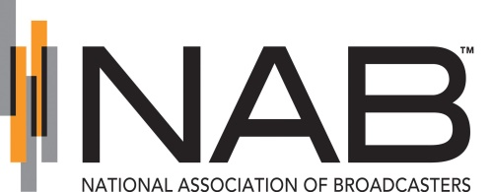
The National Association of Broadcasters is asking the Federal Communications Commission to relax rules governing the amount of educational and informational programming that full-time broadcasters are required to air per week, suggesting a switch to an annual requirement with flexibility for scheduling.
Broadcasting & Cable 6/17/19
https://www.broadcastingcable.com/news/nab-pitches-kid-friendliness-of-politics-high-school-sports

