NAB PILOT Group Pushes For Radio In Android Auto
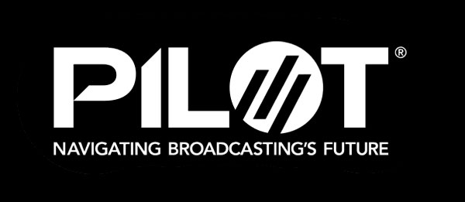
John Clark, executive director of the National Association of Broadcasters' PILOT program, says a group working toward ensuring broadcast radio is included in the Android Automotive standalone platform is ready to make its case to Google. Clark hopes to showcase how radio could fit in the platform at the upcoming NAB Show.
Radio World 3.9.22
https://www.radioworld.com/news-and-business/news-makers/android-automotive-project-completes-first-phase?utm_source=SmartBrief&utm_medium=email&utm_campaign=45863C53-9E40-4489-97A3-CC1A29EF491D&utm_content=6B17F695-9233-4746-B034-93850ABF6D71&utm_term=a25693a1-51b6-4112-bde4-56bd420e983f

