NAB, RAB Go Digital for 2020 Radio Show
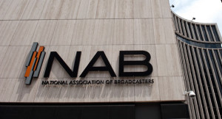
The National Association of Broadcasters and the Radio Advertising Bureau have opted to replace their 2020 Radio Show, scheduled to be held in September, with a virtual event amid concerns about the ongoing pandemic -- a move 72% of Inside Radio poll respondents support.
Radio and Television Business Report 6/3/20
https://www.rbr.com/nab-rab-cancel-2020-radio-show-set-for-music-city/

