NAB to Congress: Pass shield law
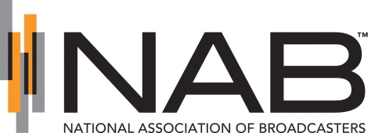
The National Association of Broadcasters and other member groups in a coalition called News Media for Open Government are asking Congress to pass a shield law that would increase press protections on the federal level; the groups are also asking Congress to address compliance and litigation costs related to the Freedom of Information Act.
Broadcasting & Cable 1/18/19
https://www.broadcastingcable.com/news/journalists-press-for-shield-law

