What Marketers Need To Know As NIL Enters Second Year
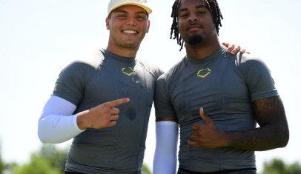
Some 72% of name, image and likeness deals with college athletes center on social media and influencer content, and 40% of those deals involve football players, according to research by University of Vermont's Bill Carter. As the NIL market enters its second year, brands, athletes, tech companies and lawmakers are still shaping this burgeoning industry, and Sports Illustrated's Richard Johnson notes, "Athletes offer brands a unique opportunity as influencers audiences can not only connect with, but actually root for."
SmartBrief/Marketing 8/9/22
https://corp.smartbrief.com/original/2022/08/how-nil-market-is-shaping-up-for-brands-athletes?utm_source=brief
Image credit:
https://corp.smartbrief.com/wp-content/uploads/2022/08/Gabriel_and_Farooq-726x420.jpg

