NBC, Comcast Restrictions to be Lifted in 2018
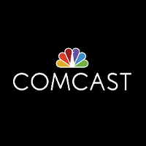
Government restrictions imposed after Comcast purchased NBCUniversal are to be lifted in 2018. The lifting of more than 150 rules will give NBC leverage with TV distributors and will allow the network to launch its own video service.
Bloomberg 4/13/17
https://www.bloomberg.com/news/articles/2017-04-13/comcast-gets-unshackled-with-nbc-deal-curbs-expiring-next-year

