NBC Sports Philadelphia New Studio With Flexible, LED-Driven Design
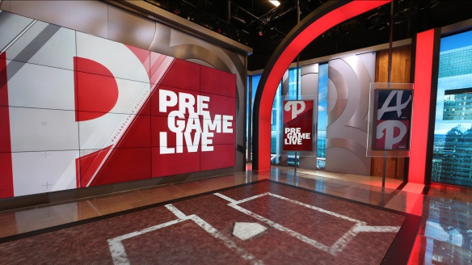
“Our new studios feature the latest in interactive technology, which will allow our hosts, analysts and insiders to engage with each other and Philly sports fans like never before,” said NBC Sports Philadelphia president Brian Monihan. “This allows us to showcase our content in new and innovative ways that allows us to drive our business forward, while also doubling down on our commitment to the fans we serve.”
NewsCastStudio 3.28.19
https://www.newscaststudio.com/2019/03/28/nbc-sports-philadelphia-broadcast-studio-a/?utm_source=Listrak&utm_medium=Email&utm_term=NBC+Sports+Philadelphia+Debuts+New+Studio+With+Flexible%2c+LED-Driven+Design&utm_campaign=Blackstone+Out+Of+Auction+For+Nielsen
Image credit:
https://www.newscaststudio.com/wp-content/uploads/2019/03/NCS_NBC-Sports-Philly-Studio-A_013.jpg

