NBCU's Peacock Unveils Frame, In-Scene Ads
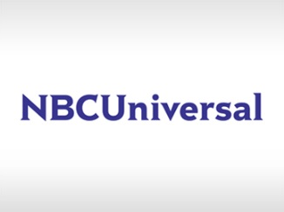
NBCUniversal's Peacock used its NewFronts presentation to launch Frame Ads, which surround video content, and can be targeted based on factors like viewers' location and interests and include e-commerce tie-ins via QR codes. Peacock also is testing In-Scene Ads such as a billboard in the background of a show's scene based on consumer watch history and perceived interests.
FierceVideo 5.2.22
https://www.fiercevideo.com/advertising/peacock-showcases-two-new-streaming-ad-formats-newfronts

