NBCU Invites Rival Networks To One23
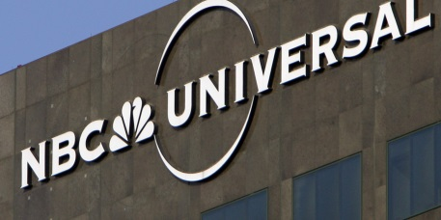
NBCUniversal is inviting rival networks to participate at its One23 conference about audience measurement, which will focus on the Joint Industry Committee NBCU has created. Panels will include executives from major companies such as Paramount, TelevisaUnivision, Dentsu International and Apple.
Next TV/Broadcasting+Cable 2/1/23
https://www.nexttv.com/news/nbcu-lets-rivals-in-spotlight-to-hype-measurement-committee?utm_term=A25693A1-51B6-4112-BDE4-56BD420E983F&utm_campaign=46D8BE3E-0142-457E-B195-A1325C099C61&utm_medium=email&utm_content=68B9C981-1FDB-4D61-82A5-3D1920493B10&utm_source=SmartBrief

