NBCU Joins Hulu's Live-Streaming Service
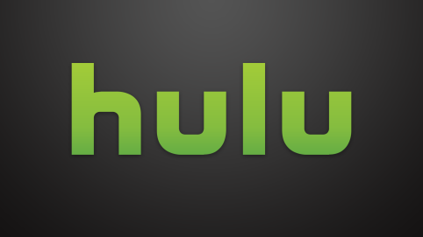
Hulu has signed a deal with NBCUniversal to bring 15 NBCU channels to Hulu's upcoming live-streaming service. The company is also focusing on releasing more original content, with shows including "The Handmaid's Tale," "Future Man" and "Castle Rock" among the original programs to debut this year.
Broadcasting & Cable 5/1/17
http://www.broadcastingcable.com/news/currency/nbcu-agrees-stream-networks-hulu-live-service/165424

