NBCU Launches Shoppable Ad Tools
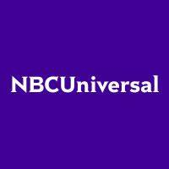
NBCUniversal's Peacock has partnered with Kerv Interactive to make on-screen products interactive, giving viewers the opportunity to purchase the exact or similar items offered by brand partners via remote control using NBCUniversal Checkout. NBCU also is launching its Retail Media Extension Network, "a self-service suite of contextually relevant shoppable native ad placements," and partnered with The Daily Mail to make its site content shoppable with NBCUniversal Checkout.
Fierce Video 2.8.23
https://www.fiercevideo.com/advertising/nbcu-brings-shoppable-tv-peacock-plans-license-content-commerce-platform

