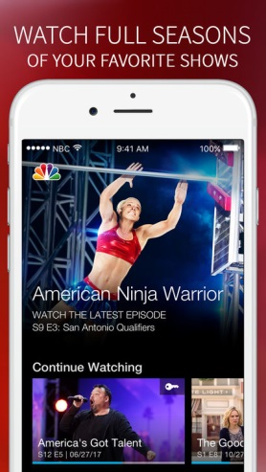
NBCU Rolls Out WatchBack App
NBCUniversal has launched promotional research tool WatchBack app in hopes of increasing its fan base for its new shows. Users of the app are entered in a contest to win points for shows they watch; they can redeem the points with participating merchants such as Amazon, SiriusXM and Target.
Variety 10/5/18
https://variety.com/2018/digital/news/nbcuniveral-watchback-app-launch-gift-cards-1202971047/
Image credit:
https://is2-ssl.mzstatic.com/image/thumb/Purple128/v4/65/57/02/6557021a-d1ed-b65e-2f52-3fac0ecbc373/source/750x750bb.jpeg

