ESPN Signs $920M, 8-Year Deal To Keep NCAA Rights
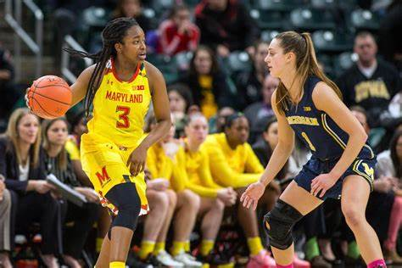
A new eight-year, $920 million deal between ESPN and the NCAA will let the Disney-owned sports network maintain its rights to NCAA championships and March Madness -- but at 300% the price of its previous 14-year deal. The agreement requires the NCAA and ESPN to cooperate on maximizing exposure opportunities and guarantees ABC will air the Division I women's basketball, volleyball and gymnastics championships and the Football Championship Subdivision each year.
Variety 1.4.24
https://variety.com/2024/tv/news/espn-ncaa-eight-year-renewal-920-million-1235861710/#
Image copyright:
https://cdn.vox-cdn.com/thumbor/YoxtoPNYHGljolLzuRJ9pZSSAz0=/0x0:3640x2424/1200x800/filters:focal(825x512:1407x1094)/cdn.vox-cdn.com/uploads/chorus_image/image/63259120/usa_today_12318781.0.jpg

