NCAA Tournament Generated $1B From TV Ads
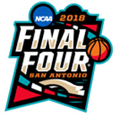
The three-week 2018 NCAA Basketball Tournament on TBS, truTV, TNT and CBS attracted $1 billion in total advertising investment, up 5.4% from 2017, per iSpot.tv. Advertisers ran a total of 391 ads, which aired 6,761 times.
MediaPost Communications 4/3/18
https://www.mediapost.com/publications/article/317061/march-madness-grows-5-in-national-tv-ad-dollars.html
Image credit:
http://www.tournamentmerch.com/assets/images/2018%20NCAA/LOGO.jpg

