Nearly A Third Of All US Media Time Will Be On Mobile This Year
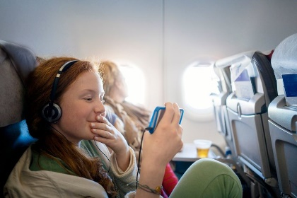
Mobile will account for close to a third (33.2%) of time spent with any form of media in 2021. By the end of 2023, that share will climb to 35.0%. The 4:23 per day that the average US adult will spend on mobile this year will also account for 54.8% of the 7:59 of daily time spent with digital media.
eMarketer 6.15.21
https://www.emarketer.com/content/nearly-third-of-all-us-media-time-will-on-mobile-this-year?ecid=NL1001
Image credit:
https://blog.assets.seeqr.com/2019/09/girl-watching-tv-phone-on-plane.jpg

