Nearly Half of Super Bowl Viewers Plan To Stream the Game
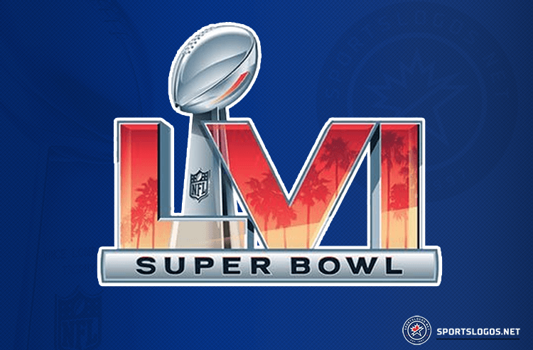
The digital marketing agency Adtaxi has released a new survey showing an accelerated shift towards streaming. It found that nearly half (49%) of consumers planned to stream the Super Bowl and that two thirds (64%) of consumers choose streaming as their preferred method of content consumption.
Media Play News 2/2/22
https://www.mediaplaynews.com/data-super-bowl-tv-viewership-to-barely-top-digital-streamers/
Image credit:
https://content.sportslogos.net/news/2021/02/super-bowl-lvi-logo-super-bowl-56-logo-los-angeles-2022-sportslogosnet-la-nfl-super-bowl-logo.png

