Nielsen Intros Wearables, Works On Engagement
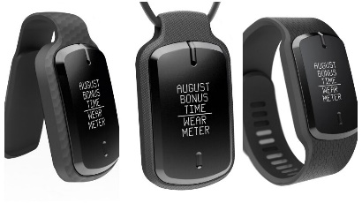
Nielsen is rolling out wristband, clip and pendant versions of its PPM devices, and estimates that it will give them to between half and three-quarters of people on its panels before 2023. The ratings firm also reports that it's investigating ways to increase engagement among younger demographics.
Radio Ink 4/1/22
https://radioink.com/2022/04/01/nielsen-wearables-to-be-rolled-out-this-year/
Image credit:
https://www.thewrap.com/wp-content/uploads/2021/08/BeFunky-collage-2021-08-03T161928.748-1-936x527.jpg

