Federal Court Lets Calif. Enforce Net Neutrality Law
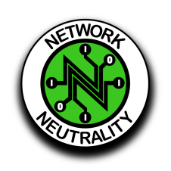
California will be able to enforce a 2018 net neutrality law after a federal district court judge declined to block its enactment over the objections of internet service providers and some trade groups. US District Court Judge John Mendez disagreed with the argument that federal law preempted the state measure, declining a request from ISPs for an injunction.
Next TV/Multichannel News 2.23.21
https://www.nexttv.com/news/court-clears-way-for-california-net-neutrality-law

