Net Neutrality Rules to be Abolished by FCC
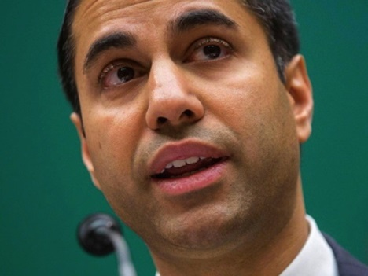
Federal Communications Commission Chairman Ajit Pai has announced a proposal that would repeal Obama administration regulations that curbed internet service providers from charging additional fees for high-quality streaming and other content or slowing down the delivery of websites. While good news for ISPs, digital companies have expressed dismay, with Facebook's Erin Egan saying, "We are disappointed that the proposal announced today ... fails to maintain the strong net neutrality protections that will ensure the internet remains open for everyone."
Media Post Communications 11.21.17
https://www.mediapost.com/publications/article/310564/fcc-poised-to-repeal-net-neutrality-block-state-b.html

