Net Neutrality Ruling Makes Washington State Unique
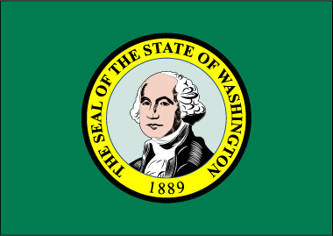
The federal appeals court's Oct. 1 decision on net neutrality legalized Washington's ability to enforce its new law, making the state the only governmental entity that is applying rules that directly affect internet service providers. Other states that have passed similar legislation are either not enforcing them yet or are indirectly regulating ISPs.
Ars Technica 10/15/19
https://arstechnica.com/tech-policy/2019/10/net-neutrality-is-still-the-law-in-washington-state/

