Netflix Acquires Video Game Developer
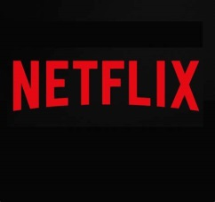
The deal, financial terms of which were not disclosed, will mean that Night School Studio will begin creating games that will be available for free as part of a Netflix membership, in addition to completing its work on the Oxenfree sequel.
Adweek 9.30.21
https://www.adweek.com/convergent-tv/netflix-acquires-night-school-studio/?utm_content=summary_component&utm_source=postup&utm_medium=email&utm_campaign=FirstThingsFirst_Newsletter_210930055015&lyt_id=1418028

