Netflix Content Spending Predicted to Rise 26% in 2021
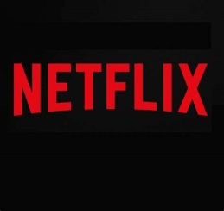
Amortized spending on movies and TV shows by Netflix will rise 26% to $13.6 billion in 2021 and will reach $18.92 billion by 2025, according to predictions published Thursday by S&P Global Market Intelligence's Kagan media research division.
NextTV 9.23.21
https://www.nexttv.com/news/netflix-content-spending-predicted-to-rise-26-in-2021?utm_source=Listrak&utm_medium=Email&utm_term=Netflix+Content+Spending+Predicted+To+Rise+26%25+Across+2021&utm_campaign=Talking+TV%3a+The+Future+Of+Video+Advertising

