Netflix Makes First Acquisition with Comic-Book Publisher
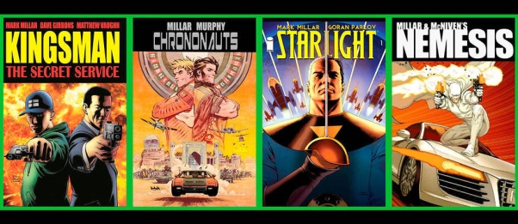
Netflix agreed to buy Millarworld, the publisher behind characters and stories like "Kingsman" and "Old Man Logan," for an undisclosed amount. Netflix and Millarworld founder Mark Millar will jointly produce films, series and children's shows based on comic-book characters for the streaming service.
Advertising Age 8.7.17
http://adage.com/article/media/netflix-makes-acquisition-comic-book-publisher/310048/?utm_source=daily_email&utm_medium=newsletter&utm_campaign=adage&ttl=1502758559&utm_visit=113450
Image credit:
http://www.lepoint.fr/images/2017/08/08/9669402lpw-9669477-article-jpg_4474712_980x426.jpg

