Netflix Pays $20 Million for Workplace Drama 'Fair Play'
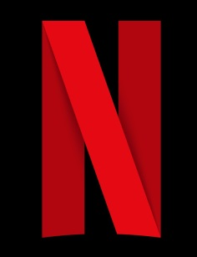
Netflix decisively signaled Monday that it is far from through with the often pricey prestige indie film business, successfully bidding a widely reported $20 million at the Sundance Film Festival to acquire director workplace relationship drama Fair Play.
TheWrap 1/23/23
https://www.thewrap.com/sundance-drama-fair-play-netflix/

