Netflix Sees Animation as Major Weapon in Streaming Wars
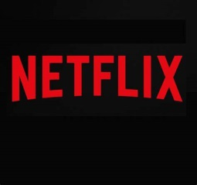
Netflix's two nominations for animated film Oscars only mark the start of the streaming service's plan to invest in animated original content as a way of competing against Disney+, executives say. Ted Sarandos, the company's chief content officer, recently told analysts about Netflix's ambitious animation plans, explaining that the films in production are "big scale feature films that would be competitive with anything you'd see in the box office."
CNBC 2.9.20
https://www.cnbc.com/2020/02/08/how-netflix-plans-to-use-animation-to-challenge-disney-plus.html

