Netflix Stands to Lose Fox Content After Disney Deal
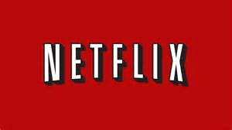
Disney has already announced that it will be removing its content from Netflix in 2019, but its planned deal with Fox could see content such as "Family Guy" and "Avatar" also removed from the streaming service. Disney CEO Bob Iger has said that the company is focusing on building a streaming platform using its own content, as well as assets it hopes to acquire from Fox.
USA Today 12/27/17
https://www.usatoday.com/story/tech/talkingtech/2017/12/27/disney-remove-fox-content-netflix-hbo-its-likely-matter-time/952177001/

