Netflix Surpasses Comcast In Market Value
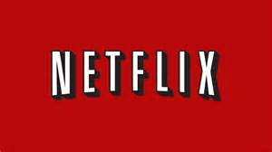
Netflix surpassed Comcast in market value on Wednesday in a possible sign of consumers’ growing preference for video streaming services over traditional television subscriptions. On Wednesday, Netflix ended the trading day with a market capitalization of about $152.8 billion, overtaking Comcast’s market value of $147 billion.
The Hill 5.24.18
http://thehill.com/policy/technology/389105-netflix-surpasses-comcast-in-market-value

