Netflix Takes Baby Steps Into Video Gaming
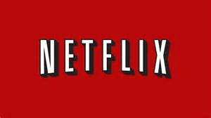
Netflix announced that it would work with developer Next Games to create a third mobile game based on its hit series Stranger Things. That game, expected to be available in 2020, follows the debut of Stranger Things: The Game from 2017. Stranger Things 3: The Game also drops July 4, the same day the third season of the show premieres.
Fortune 6.12.19
http://fortune.com/2019/06/12/netflix-video-games/?utm_source=Listrak&utm_medium=Email&utm_term=Netflix+Takes+Baby+Steps+Into+Video+Gaming&utm_campaign=Stations+Get+Creative+To+Monetize+OTT+Offerings

