Netflix Tests Option That Picks Viewers' Next Show
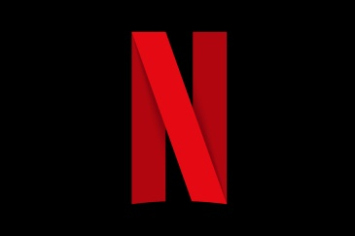
Netflix is trying out a "Shuffle Play" feature that automatically selects a program based on a subscriber's history. The company says connected television viewers make up the function's trial group.
Next TV 8.19.20
https://www.nexttv.com/news/netflixs-new-shuffle-play-feature-automatically-chooses-your-shows

