Netflix Throws Itself Further Into Original Content
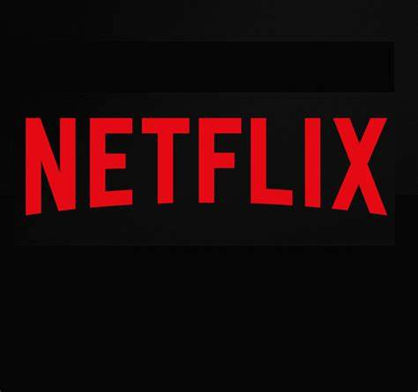
Netflix is forecast to spend more on original programming than ever before, splitting its global content budget almost evenly between that and licensing costs. In four years, 46.5% of the streaming giant’s projected $18.92 billion budget will go toward originals, compared with 37.8% in 2020.
eMarketer 11.3.21
https://www.emarketer.com/content/netflix-throws-itself-further-original-content/?IR=T&utm_source=Triggermail&utm_medium=email&utm_campaign=II20211104NetflixCOTD&utm_term=New%20COTD%202020

