It's Netflix's World, Disney Just Lives in It
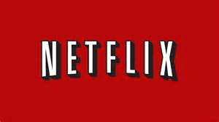
Netflix Inc. firmly established itself as the world’s most valuable media company. An 11-year-old app that charges $11 a month is worth more to investors than the legacy conglomerates that earn billions more from TV advertising, box-office hits and cable and internet packages.
Bloomberg 6.1.18
https://www.bloomberg.com/view/articles/2018-06-01/netflix-disney-and-comcast-can-coexist

