New Streaming Originals Spell New Subscribers—And New Costs
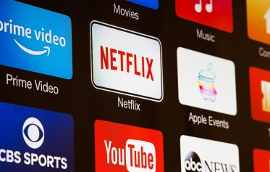
Four of the top US streaming services spent a record-smashing total of $11.15 billion on original content in 2021 as each platform vied to draw—and keep—subscribers. Netflix laid out $6.08 billion, more than the other three services combined. Amazon Prime Video grew its spending the fastest, by 105.3%, in a play for Netflix’s title as the leading subscription video streamer.
eMarketer 3.2.22
https://www.emarketer.com/content/streaming-originals-spell-new-subscribers/?IR=T&utm_source=Triggermail&utm_medium=email&utm_campaign=II20220303StreamingContentCOTD&utm_content=Final&utm_term=New%20COTD%202020
Image credit:
https://www.nme.com/wp-content/uploads/2020/11/Streaming-Services.jpg

