Newspapers Gobble Up Each Other to Survive Digital Apocalypse
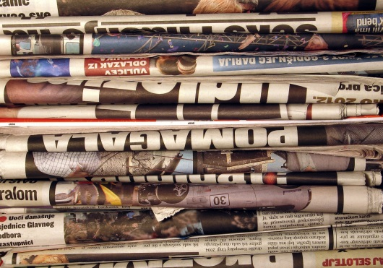
Last year, the industry saw the most deals for the largest amount of money since the 2008 financial crisis, with 70 daily newspapers being sold for a combined $827 million, according to mergers-and-acquisitions adviser Dirks, Van Essen & Murray. Even after last year's surge of activity, more deals may be coming.
Advertising Age 3.29.16
http://adage.com/article/media/newspapers-gobble-survive-digital-apocalypse/303313/?utm_source=daily_email&utm_medium=newsletter&utm_campaign=adage&ttl=1459896993

