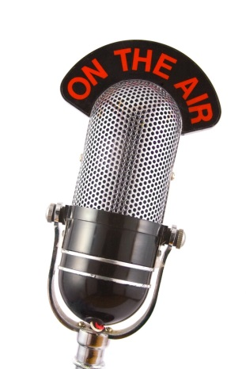
News/Talk Radio Proves to be a Big Hit in 2016
News/talk radio closed out the year as radio's highest-rated format thanks to higher-than-average shares stemming from election coverage. With President Trump now in office, stations must maintain momentum to keep up with constantly changing news.
Inside Radio 1/30/17
http://www.insideradio.com/in-trumpian-world-news-talk-moves-to-maintain-momentum/article_0b7f4b1a-e6be-11e6-8c25-97099401d245.html
Image source:
http://bucketsandbows.com/wp-content/uploads/on-the-air-microphone1.jpg

