NextGen Signal Launches At 6 Philadelphia Stations
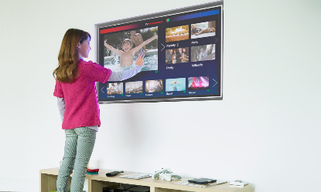
Six television stations in the Philadelphia market have launched NextGen TV broadcast signals. The free over-the-air service is now available in over 65 US markets and expected to reach 75% of US households by the end of this year.
TVNewsCheck (free registration) 8.10.23
https://tvnewscheck.com/tech/article/six-stations-launch-nextgen-tv-in-philadelphia/
Image credit:
https://www.americantower.com/Assets/beta.americantower.com/uploads/images/blog/next-gen-tv.jpg

