NextGen TV Debuts On 6 Grand Rapids Stations
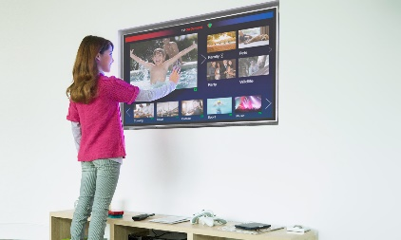
Based on the same fundamental technology as the Internet, digital applications, and other web services, NextGen TV can support a wide range of features currently in development, such as immersive audio and video (up to 4K), broadcasting to mobile devices, personalized viewing tools, and advanced emergency alerts providing rich media instead of simple text messages.
TVNewsCheck 5.7.21
https://tvnewscheck.com/top-news/tech/article/nextgen-tv-debuts-on-6-grand-rapids-stations/?utm_source=Listrak&utm_medium=Email&utm_term=NextGen+TV+Debuts+On+6+Grand+Rapids+Stations&utm_campaign=Scripps+1Q+Station+Revenue+Down+3.8%25
Image credit:
https://www.americantower.com/Assets/beta.americantower.com/uploads/images/blog/next-gen-tv.jpg

