NFL Considers Selling Media Stakes
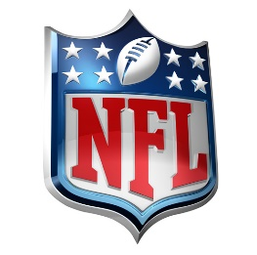
The National Football League may sell stakes in the NFL Network, NFL RedZone and other media properties to major technology or media companies that can expand those outlets' reach, but spokespeople say the league will retain control. Goldman Sachs is helping the NFL to locate possible partners.
The Hollywood Reporter 6/23/21
https://www.hollywoodreporter.com/business/business-news/nfl-exploring-sale-nfl-network-1234972910/

