NFL Coverage Continues To Deliver Broadcast Ratings
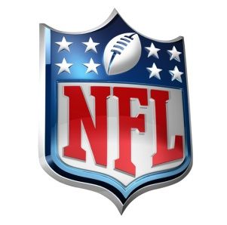
NFL games, pre-game shows or post-game coverage made up nine of the top ten broadcast television programs in the last week by viewership, Nielsen data indicates. CBS and Fox both reported double-digit increases over last year, while ratings for NBC's "Sunday Night Football" were the highest they've been since 2015.
Poynter 9.14.22
https://www.poynter.org/commentary/2022/football-dominates-tv-ratings-fall-2022/

