NFL Radio Reaches More High-Income Listeners
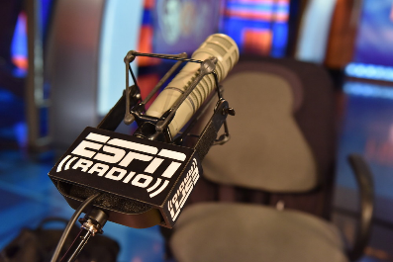
Audiences tuning into radio broadcasts of NFL games are more likely to be educated and have higher incomes than the average listener, Nielsen data indicates, noting on average, 66% of NFL radio audiences have a household income over $75,000 compared to 53% of total radio audiences. Nielsen found 45% of NFL listeners have a college degree compared to 36% of all radio audiences.
Inside Radio 11/14/23
https://www.insideradio.com/free/nielsen-nfl-on-radio-reaches-highly-desirable-consumers/article_b57ce826-82c9-11ee-a9a2-ebc35e4a445a.html
Image credit:
https://espnpressroom.com/us/files/2020/09/RS405788_20151026_020-mar.jpg

