NFL Scores With Bigger TV Deals, Amazon Agreement
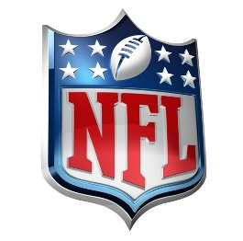
The National Football League has signed contracts with Amazon, Disney, Fox, NBCUniversal and ViacomCBS, worth a combined $113 billion, which start during 2023 and will last for 11 seasons. Amazon has reportedly dropped $10 billion to stream 15 episodes of "Thursday Night Football" exclusively outside of teams' local markets.
Vox 3.18.21
https://www.vox.com/recode/22338794/amazon-nfl-10-billion-tv-analysis

